User Guide
Intelligent Transportation Systems Deployment Tracking Surveys (1999 – 2020)
www.its.dot.gov/index.htm
Updated October 2024



Table of Contents
Chapter 1. Introduction 1
Chapter 2. ITS Deployment Tracking Survey Methodology 2
ITS Deployment Tracking Surveys (1999 – 2020) 2
Development of the Survey Sample 2
Updates to the Survey Sample 3
ITS Deployment Tracking Survey Data Limitations (1999 – 2020) 4
Special Topic Deployment Surveys 5
2019 Connected Vehicle and Automated Vehicle Survey 5
2019 Small Urban and Rural Transit Survey 5
Electronic Toll Collection Surveys 6
Incident Management/Public Safety Surveys 6
Metropolitan Planning Organization Surveys 6
Statewide ITS Systems Surveys 6
Transportation Management Center Surveys 6
Chapter 3. Contents of Past ITS Deployment Tracking Surveys and Special Topic Deployment Surveys 7
ITS Deployment Tracking Surveys (1999 – 2020) 7
Special Topic Deployment Surveys 7
Chapter 4. Common Survey Questions 9
Index Worksheet 9
Topic Worksheets 11
Chapter 5. Survey Data Files for ITS Deployment Tracking Survey (1999 – 2020) 13
Data Preparation 13
Data Worksheet 14
Data Dictionary 14
Variable Summary Statistics 15
Chapter 6. Use Cases 16
Use Case 1: Extracting Data from Past ITS Deployment Tracking Surveys (1999 – 2020) for a Trend 16
Use Case 2: Extracting Data from Past ITS Deployment Tracking Surveys (1999 – 2020) for a Particular Agency 18

List of Figures
Figure 1: Index Worksheet in Freeway Management Common Survey Questions File 10
Figure 2: Expanded Index Worksheet in Freeway Management Common Survey Questions File 11
Figure 3: Topic Worksheet for “511” in Freeway Management Common Survey Questions File 11
Figure 4: Expanded “511” Topic Worksheet in Freeway Management Common Questions File 12
Figure 5: Data Worksheet in Survey Data File 14
Figure 6: Data Dictionary Worksheet in Survey Data File 14
Figure 7: Variable Summary Statistics Worksheet in Survey Data File 15
Figure 8. Use of the Index Worksheet to Identify Ramp Meter Questions 17
Figure 9. Use of the “Ramp Meters” Tab to Identify Trend for the Metered Ramps Question 17
Figure 10. Metered Ramps Data Extracted From Multiple Surveys 18
Figure 11. Use of the Index Worksheet to Identify Connected Vehicle Questions 19
Figure 12. Use of the “Connected Vehicles” Tab to Obtain Information About the Connected Vehicle Applications Question 19
Figure 13. 2016 Connected Vehicle Data for New York State Department of Transportation 20

List of Tables
Table 1. Substantial Changes in Metropolitan Statistical Area Definitions 21

Acronyms
Acronym | Meaning
AV | Automated Vehicle
CV | Connected Vehicle
ETC | Electronic Toll Collection
GAO | General Accountability Office
ICM | Integrated Corridor Management
ITS | Intelligent Transportation Systems
ITS JPO | Intelligent Transportation System Joint Program Office
IVHS | Intelligent Vehicle Highway Systems
MPO | Metropolitan Planning Organizations
MSA | Metropolitan Statistical Areas
NTD | National Transit Database
RCI | Roadway Congestion Index
SMEs | Subject Matter Experts
TMC | Transportation Management Centers
USDOT | United States Department of Transportation

Introduction
This document is a user guide for the Intelligent Transportation Systems (ITS) Deployment Tracking Surveys conducted during the period 1999 – 2020. The goal of establishing a data repository for these past ITS Deployment Tracking Surveys is to make the extensive amount of deployment data collected from 1999 to 2020 by the United States Department of Transportation (USDOT) Intelligent Transportation System Joint Program Office (ITS JPO) available to researchers, policy makers, and other interested parties for exploration, analysis, and use.
With the most recent ITS Deployment Tracking Survey, conducted in 2023, the ITS JPO used a new sampling methodology that greatly expanded the scope of the surveys to include smaller urban and rural areas, in addition to large metropolitan areas. As a result, a separate User Guide, ITS Deployment Tracking Survey User Guide (2023), was prepared to accompany the 2023 datasets, questionnaires, and reports. See: https://www.itskrs.its.dot.gov/deployment/2023DTS.
The data repository for the ITS Deployment Tracking Survey includes data from past ITS Deployment Tracking Surveys (1999 – 2020) as well as Special Topic Deployment Surveys administered during the same twenty year period. The ITS Deployment Tracking Surveys were conducted a total of 11 times between 1999 and 2020 and were administered to freeway management, arterial management, and transit management agencies in a subset of large metropolitan areas. In addition, the ITS JPO conducted a number of Special Topic Deployment Surveys, including the 2019 Connected Vehicle (CV) and Automated Vehicle (AV) Survey, the 2019 Small Urban and Rural Transit Survey, and surveys related to Electronic Toll Collection (ETC), Incident Management/Public Safety, Statewide ITS Systems, Metropolitan Planning Organizations (MPO) and Transportation Management Centers (TMC).
The various deployment tracking survey instruments were designed to collect data characterizing ITS technology deployment, as well as programs and policies implemented to support ITS. The ITS JPO initiated the ITS Deployment Tracking Survey in response to U.S. Transportation Secretary Peña’s goal (established in 1996) that the 75 largest metropolitan areas should be outfitted with an integrated ITS infrastructure in the next ten years. During the ten-year goal period, the survey was conducted annually to track ITS deployment progress toward the Secretary of Transportation’s goal. Following the goal period, the ITS JPO has conducted the survey every two to three years and continued to use the survey to measure ITS deployment progress in a subset of large metropolitan areas.

ITS Deployment Tracking Survey Methodology
This chapter provides a high-level overview of the methodology used for the ITS Deployment Tracking Surveys conducted from 1999 to 2020 and the Special Topic Deployment Surveys.

ITS Deployment Tracking Surveys (1999 – 2020)
Data collection during the first few years of the ITS Deployment Tracking Survey centered on the nation’s largest metropolitan areas. The ITS JPO determined it would track progress toward the USDOT goal using a survey. The USDOT had published a list of the nation’s largest metropolitan areas in a 1994 Federal Register in support of the Intelligent Vehicle Highway Systems (IVHS) Early Deployment Planning Program. The ITS JPO used this list as the basis for the Deployment Tracking Survey; however, the ITS JPO included an additional three metropolitan areas identified to be among the largest in the nation.

Development of the Survey Sample
To develop the sample of agencies that would be surveyed, deployment tracking boundaries, based on MPO boundaries in each metropolitan area, were identified. As described in the initial 1997 ITS Deployment Tracking Survey Report, MPO boundaries were used for the following reasons:
- This boundary is used for transportation planning activities in a region and is therefore more likely to be the basis for other similar inventory efforts.
- This boundary identifies the concentration of planning and programming for a region and therefore will be the focus of ITS planning and programming over the next decade.
- This boundary is established without regard to municipal jurisdiction and provides a regional basis to describe an area.

The 1997 ITS Deployment Tracking Survey Report further describes the selection of agencies as follows:
Within the tracking boundary area, selected operating and planning agencies were identified, and surveys were distributed following the general guidelines outlined below. In some cases, these rules were not strictly followed based on discussions with Region and Division FHWA and FTA staff. In most cases, however, distribution of surveys followed these guidelines.
Emergency Management, Highway-Rail Intersection, and Traffic Signal Control surveys were administered to the following agencies:
- County government agencies located wholly or partially within the metropolitan area for which the metropolitan transportation planning process is conducted for at least 50,000 persons
- City government agencies with a population of 50,000 or more persons within the metropolitan area
- State DOT
Transit Management and Electronic Fare Payment surveys were distributed to each operator of public transportation in the metropolitan area as reported in the National Transit Database (NTD) (formally, Section 15).
Freeway Management, Incident Management, ETC and Regional Multimodal Traveler Information surveys were distributed to state transportation departments and toll operators, as appropriate.
Contacts were identified for each agency and a database containing the name, address, telephone number, and email address of each contact was developed. Prior to administering each ITS Deployment Tracking Survey, the research team notified all contacts of the upcoming survey and requested that they confirm whether or not they are the appropriate contact. The research team developed alternate contacts as needed.

Updates to the Survey Sample
In 2002, the survey population expanded to include 30 additional metropolitan areas estimated to have a high Roadway Congestion Index (RCI) based on an analysis of data from Highway Statistics 2000.
Since the inception of the ITS Deployment Tracking Survey, there are two additional changes that should be noted.
- The 2002 survey included a one-time addition of 20 additional metropolitan areas identified as highly rated tourist locations based on the 2000 Census seasonal, recreational, and occasional use properties.
- In 2010, the Arterial Management Survey was administered to only 53 metropolitan areas. As a result, the 2010 Arterial data should not be used in trend analyses.

A total of 11 ITS Deployment Tracking Surveys were conducted in the following years: 1999, 2000, 2002, 2004, 2005, 2006, 2007, 2010, 2013, 2016, and 2020. Over time, the cities and corresponding agencies being surveyed have remained consistent; however, in a few cases the names and definitions of the metropolitan areas covered under the survey population have changed due to changes resulting from the 2000 Census. Please see Appendix A for more information. As of 2013, 114 metropolitan areas are included in the survey population.
Originally, five types of surveys were developed: Freeway Management, Arterial Management, Transit Management, ETC, and Incident Management/Public Safety (ETC and Incident Management/Public Safety surveys are described in more detail below under “Special Topic Deployment Surveys”).
Questions for each survey were developed through a consultative process conducted with USDOT subject matter experts (SMEs) to ensure continued relevancy of survey results. Selected questions were repeated each year so trends could be developed for tracking purposes. However, some questions were revised to reflect changes in program and/or practice. In the early years of the ITS Deployment Tracking Survey, data collection focused on intelligent infrastructure components such as surveillance and control technologies. In recent years, data collection expanded to include concepts such as Integrated Corridor Management (ICM) and CV and AV technologies.
Surveys in the first few years were self-administered paper survey instruments that were completed by hand and returned via mail. Starting in 2004, agency contacts were emailed a link to complete an online survey. Follow-up emails and telephone calls were then made to encourage responses.

ITS Deployment Tracking Survey Data Limitations (1999 – 2020)

Missing Values
The data collected reflect the responses provided by agency staff and were accepted as provided. Every effort was made to encourage agency response each year a survey was conducted. Although a large proportion of agencies responded each time the survey was conducted, other agencies responded sporadically, leaving missing values for some years.

Errors in Response
In some cases, estimates of deployment for an agency (e.g., freeway centerline miles under surveillance) may contain error due to differing interpretations by agency respondents. As an example, when asked to provide the number of freeway centerline miles under surveillance in the metropolitan area, a respondent may have provided a response related to an area larger or smaller than the metropolitan area boundary (i.e., boundary error). This type of response error may explain, at least in part, the fluctuations that exist for some of the trend data.

Special Topic Deployment Surveys
In addition to the surveys of freeway management, arterial management, and transit management agencies, the ITS JPO has administered a series of special topic surveys, which include surveys on specialized topics or surveys tailored to other agency types, such as law enforcement, public safety, and metropolitan planning organizations. Each of the surveys is described in more detail below.

2019 Connected Vehicle and Automated Vehicle Survey
The 2019 CV/AV Survey was administered as part of an ongoing effort by the ITS JPO to track the deployment of ITS. The survey focuses on CV and AV technologies and was designed to address the following key questions:
- What are current levels of CV and AV testing/deployment?
- What is agencies’ level of readiness with respect to CV and AV?
- What are the key challenges and barriers to CV and AV deployment?
- What assistance/resources are needed to overcome challenges and barriers?
The 2019 CV/AV survey utilized freeway management, arterial management, and transit management agency contact lists developed for previous ITS Deployment Tracking Surveys. These lists included agencies from 114 large metropolitan areas. Invitations to the online survey were sent to 753 freeway management, arterial management, and transit management agencies. Online data collection ran from October 7 to December 31, 2019. The final response rate was 60 percent, resulting in 475 completed surveys (66 freeway management, 301 arterial management, and 108 transit management).

2019 Small Urban and Rural Transit Survey
The ITS JPO conducted the Small Urban and Rural Transit Survey in response to a General Accountability Office (GAO) recommendation that the ITS JPO should track the deployment of ITS within small urban and rural areas. The GAO’s recommendation stemmed from its own evaluation of ITS deployment among transit providers, which included a small urban and rural transit provider survey administered in 2015. The 2019 Small Urban and Rural Transit Survey used the GAO’s original survey instrument, adding a few new questions related to CV, AV, and partnerships with private transportation providers.
To provide data comparable to the GAO’s 2015 survey, the 2019 survey replicated the GAO’s sampling methodology. The sample frame constructed from the NTD yielded 325 small urban and 621 rural transit providers. A stratified sampling approach was used to select separate samples of small urban and rural transit providers. Invitations to the online survey were sent to a sample of 152 small urban and 177 rural transit providers.
The survey was fielded between September 9 and October 28, 2019. The final response rate was 74 percent, resulting in 244 transit agency surveys (107 small urban and 137 rural transit providers). The data were weighted to accurately reflect the distribution of small urban and rural transit providers within the population. Data users should use the weighting variable [WEIGHT] when analyzing the data.

Electronic Toll Collection Surveys
ETC data were gathered from toll road and bridge operators in a subset of large metropolitan areas across the United States. The ITS JPO administered these surveys from 1999 to 2013, as part of the ITS Deployment Tracking Survey effort. Data collected included ETC technologies and bridge and toll road operations.

Incident Management/Public Safety Surveys
Incident management/public safety data were collected from fire rescue and law enforcement agencies in a subset of large metropolitan areas across the United States. The ITS JPO administered these surveys from 1999 to 2013 as part of the ITS Deployment Tracking Survey effort. Data gathered included incident management programs, policies, and technologies.

Metropolitan Planning Organization Surveys
Planning data were collected from MPOs in a subset of large metropolitan areas across the United States. The ITS JPO administered these surveys in 1999, 2000, and 2004. Data gathered included planning and coordination efforts for ITS deployment.

Statewide ITS Systems Surveys
State level data were collected from State DOTs describing the functions performed and the statewide transportation technologies located throughout the nation. The ITS JPO administered these statewide surveys in 2002, 2004, 2006, and 2007. Data included surveillance technologies as well as traffic management, traveler information programs, and funding.

Transportation Management Center Surveys
Traffic management data were collected from State DOTs describing the functions performed and the technologies applied by TMCs located throughout the nation. The ITS JPO administered these surveys in 2007, 2010, and 2013. Data included surveillance technologies as well as traffic management, traveler information programs, and funding.

Contents of Past ITS Deployment Tracking Surveys and Special Topic Deployment Surveys
The data repository includes files related to past ITS Deployment Tracking Survey (1999 – 2020) and Special Topic Deployment Surveys conducted during the same period.

ITS Deployment Tracking Surveys (1999 – 2020)
From 1999 to 2020 each survey year includes: 3 survey instruments (Freeway Management, Arterial Management, and Transit Management) and 3 data files (Freeway, Arterial, and Transit). For the surveys conducted between 1999 and 2016 there is 1 summary report. For the 2020 ITS Deployment Tracking Survey there are 4 reports (Key Findings, Freeway Management, Arterial Management, and Transit Management), as well as infographics. A description of the files is provided below.
1999 – 2020 Survey Instruments – Freeway Management, Arterial Management, and Transit Management survey instruments used to collect data from 1999 to 2020 – 33 survey files.
1999 – 2020 Deployment Data – Excel data files and data dictionaries associated with the Freeway Management, Arterial Management, and Transit Management surveys – 33 data files.
1999 – 2020 Final Reports – For each survey year from 1999 to 2016, a summary report was prepared synthesizing key findings and trends from the Freeway Management, Arterial Management, and Transit Management surveys. For the 2020 survey, four separate reports were developed (Key Findings, Freeway Management, Arterial Management, and Transit Management Reports) – 14 files.
2020 Infographics – Infographics were developed for the 2020 ITS Deployment Tracking Survey to highlight key findings from the Freeway Management, Arterial Management, and Transit Management Surveys. The infographics are organized under the following topics: Key Survey Findings, Traveler Information Findings, Performance Measures Findings, and Data Collection Findings – 9 files.
1999 – 2020 Common Survey Questions – Excel files for each survey type (Freeway Management, Arterial Management, and transit Management) that group common questions across all survey years from 1999 to 2020. The questions are organized by key topic area – 3 files.

Special Topic Deployment Surveys
A summary of the special topic survey files is provided below.
2019 Connected Vehicle and Automated Vehicle Survey – Survey instrument, Excel data files (4 data files for each Freeway Management, Arterial Management, Transit Management and 1 file combining all three), a common questions file, and a summary report – 7 files.
2019 Small Urban and Rural Transit Survey – Survey instrument, Excel data file, and a summary report – 3 files.
Note that the 2019 Small Urban and Rural Transit survey includes a weighting variable [WEIGHT] that should be used when analyzing data to accurately reflect the distribution of small urban and rural transit providers within the population.
Electronic Toll Collection Surveys (1999 – 2013) – Survey instruments for each year, Excel data files for each year, and a common questions file – 19 files.
Incident Management/Public Safety Surveys (1999 – 2013) – Survey instruments for each year, Excel data files for each year, and common questions files:
- Fire Rescue – 10 survey instruments, 10 data files, 1 common questions file – 21 files.
- Law Enforcement – 10 survey instruments, 10 data files, 1 common questions file – 21 files.

Metropolitan Planning Organization Surveys (1999, 2000, 2004) – Survey instruments for each year, Excel data files for each year, and a common questions file – 7 files.
Traffic Management Center Surveys (2002, 2004, 2007, 2010, 2013) – Survey instruments for each year, Excel data files for each year, and a common questions file – 11 files.
Statewide ITS Systems Surveys (2002, 2004, 2006, 2007) – Survey instruments for each year, Excel data files for each year, and a common questions file – 9 files.

Common Survey Questions
This chapter provides a more in-depth look at the ITS Deployment Tracking Survey 1999 – 2020 Common Survey Questions files, as they present a useful way to begin exploring the contents of the past ITS Deployment Tracking Surveys.
The common questions files provide the data user with an understanding of the topics and survey questions available for analysis. The ITS Deployment Tracking Survey 1999 – 2020 Common Survey Questions files include a separate file for the Freeway Management, Arterial Management, and Transit Management Surveys. Each file contains a complete set of questions asked in the ITS Deployment Tracking Survey instruments from 1999 to 2020.
There are additional common question files for the Special Topic Deployment Surveys, including:
- 2019 Connected Vehicle and Automated Vehicle Survey
- Electronic Toll Collection Survey
- Incident Management/Public Safety: Fire & Rescue and Law Enforcement
- Metropolitan Planning Organization Survey
- Statewide ITS Systems Survey
- Transportation Management Center Survey
While this chapter focuses on the ITS Deployment Tracking Survey 1999 – 2020 Common Survey Question files for Freeway Management, Arterial Management, and Transit Management, the common survey questions files for the Special Topic Deployment Surveys follow the same format.
Each common survey questions file includes an index worksheet summarizing the topics covered in the survey and several topic worksheets that provide detailed information including question wording, response choices, variable names, variable formats, and survey year.

Index Worksheet
The index worksheet is a guide to the contents of the various topic worksheets in the file. The index lists the topics covered in the survey from 1999 to 2020 (e.g., 511, Auto Enforcement, Incident Management, etc.). Figure 1 displays elements of the index worksheet (non-expanded) for the Freeway Management Common Survey Questions file. If a user does not see a topic they are interested in listed, consider using the search function within Excel (CRTL-F), as there may be a question on the topic in the database, even if it is not identified as an index topic.
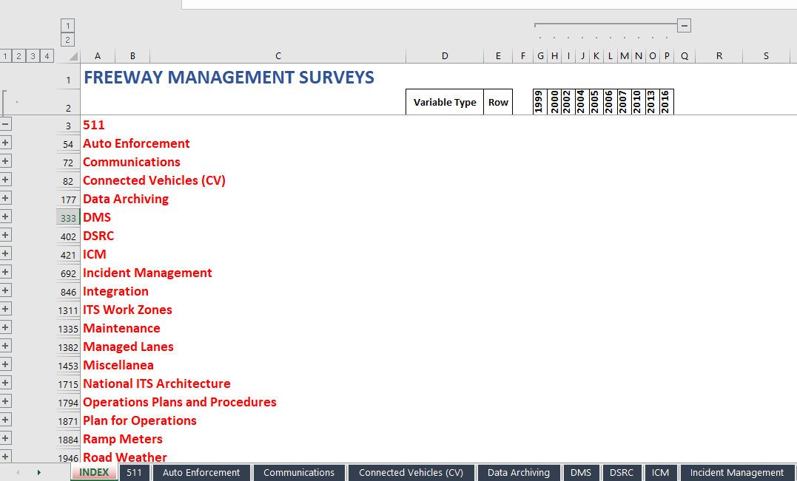
Figure 1: Index Worksheet in Freeway Management Common Survey Questions File
Initially, various rows and columns of the index worksheet are hidden to simplify the display. The appearance of the index worksheet can be changed by using various buttons (labeled 1, 2, 3, 4) and “+” or “-“symbols. Selecting these buttons, or symbols, will expand rows and columns to reveal, or hide, additional information for each topic.
Figure 2 displays the first several rows and columns for the fully expanded Freeway Management Index worksheet. Under the “511” topic, several “sub-topics” are highlighted in black including “511 Services.” Under each of these sub-topics, are included a number of rows describing question types, including one labeled “Operational 511.”
- Topic: 511
- Subtopic: 511 Services
- Question: Operational 511
- Variable Type: Multiple Choice
- Row in Topic Worksheet: 13
- Year: 2004
- Question number/wording: Q15 (hover over the year to get question number and wording)
The information provided in this figure indicates that “Operational 511” refers to a multiple choice question asked in Question 15 of the 2004 survey and located in row 13 of the “511” topic worksheet. To learn more details regarding this question, the user must turn to the “511” topic worksheet and explore rows related to the “511 Services” sub-topic.
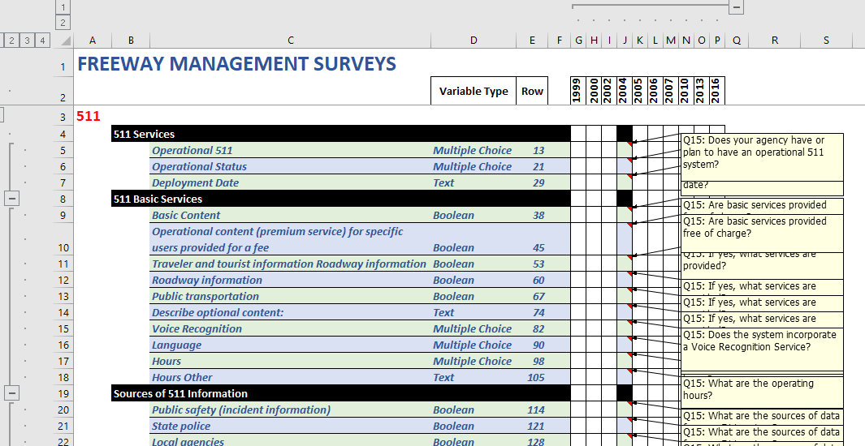
Figure 2: Expanded Index Worksheet in Freeway Management Common Survey Questions File

Topic Worksheets
Figure 3 presents the “511” topic worksheet for the Freeway Management Common Questions file.
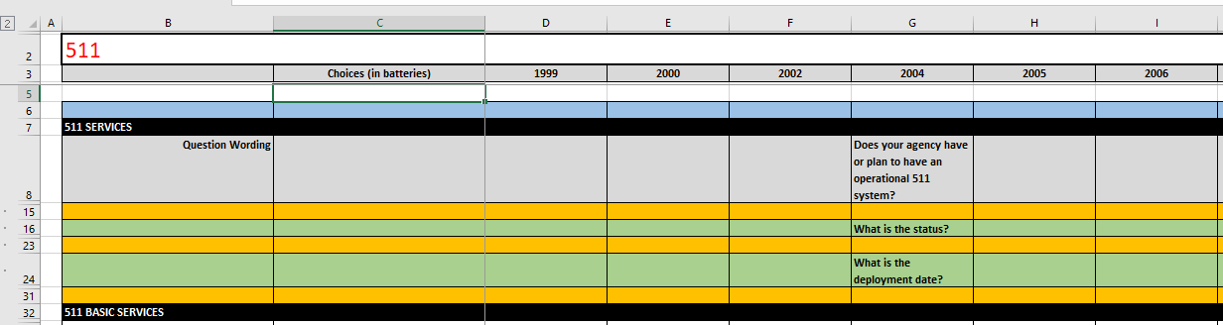
Figure 3: Topic Worksheet for “511” in Freeway Management Common Survey Questions File
Highlighted in black are sub-topics, including “511 Services.” The rows of this worksheet can be expanded (or collapsed) by selecting a numbered button (1 or 2) or a system (“+”,”-“).
Figure 4 presents the results of fully expanding the “511” topic worksheet to reveal the questions asked under the sub-topic “511 Services.” Note that the question “Does your agency have or plan to have an operational 511 system?” was asked in question 15 of the 2004 Freeway Management Survey and this question is coded in a multiple choice format (0=No;1=Yes;2=No Response).
Within the 2004 Freeway Management, this question is labeled: “04_FM_Q15_1C01R01.” Given this variable name, a user may now find the responses to this question in the 2004 Freeway Management data file.
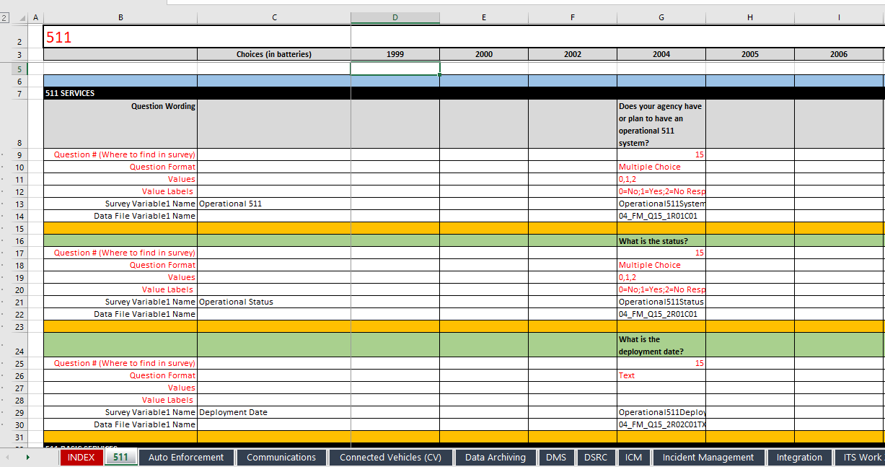
Figure 4: Expanded “511” Topic Worksheet in Freeway Management Common Questions File
It is recommended that data users explore the contents of the common survey questions files to understand the data contained in past ITS Deployment Tracking Surveys and Special Topic Deployment Surveys conducted 1999 - 2020.
The index worksheet lists the topics contained in the data and the wording of specific questions asked under a topic for a particular year or set of years. If a data user is interested in the data contained under a topic, additional details are provided under various topic worksheets in the file. Details provided in the topic worksheet include the variable names which the user can use to extract the required data from the appropriate data file.
Please note that any index worksheets (and topic worksheets) may not include all questions on the given topic. Some of the survey questions are cross-cutting, but they were categorized under a single topic based on the best fit. For example, a user interested in incident management questions would search the Incident Management Index Worksheet; however, the ICM Index also includes a question on incident management. As a result, in addition to using the index and topic worksheets, it is recommended that users also use the Excel search function (CTRL-F) for a more comprehensive search.
In addition, if users cannot find questions on a certain topic, consider searching for other, similar terms (e.g., dynamic message signs and variable message signs). Finally, users can also review the survey instruments to identify questions of interest.

Survey Data Files for ITS Deployment Tracking Survey (1999 – 2020)
This chapter provides more detailed information on the development and contents of the data files, data dictionaries, and variable summary statistics for the ITS Deployment Tracking Survey (1999 – 2020).

Data Preparation
Survey data were entered into Excel files using consistent coding formats and variable naming convention. Variables are coded using one of four formats:
- Numeric (integer value)
- Boolean (0,1)
- Multiple-Choice (integer value based on question selection options)
- Text
In addition, a consistent variable name structure was developed to ensure a unique variable name for each of the variables in the data base:
XX_XX_QXX_XRXXCXXTXT
Year
Survey
Question #
Identifier

Where:
- Year – e.g. 99,00,02, etc.
- Survey – Freeway Management (FM), Arterial Management (AM), Transit Management (TM)
- Question # – Question number in survey
- Identifier – Sub-question code
- TXT – added if variable is text format

Each Excel data file contains three worksheets: Data, Data Dictionary, and Var Summ Stats.

Data Worksheet
Figure 5 presents an example data worksheet. One record was created for each completed survey (shown as a row in the data file). The data files, although unique to each survey year, contain a set of consistent variables. The first three columns of the file contain the following variables for each record:
- MetroArea – Name of metropolitan area where agency is located
- AgencyName – Name of agency
- AgencyNumber - Unique ID number in each survey year to allow for matching of survey respondents over time
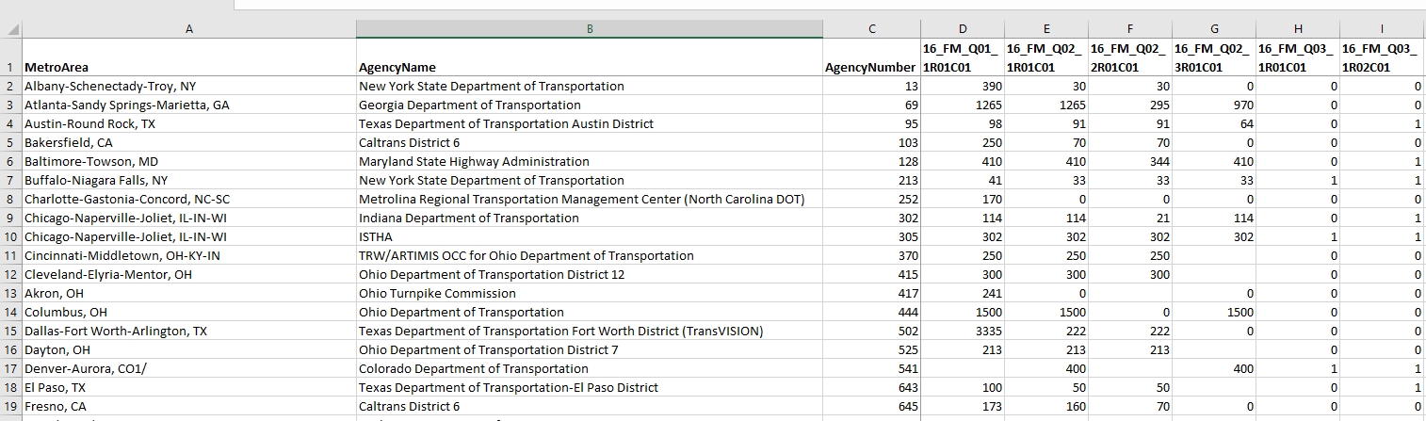
Figure 5: Data Worksheet in Survey Data File

Data Dictionary
Figure 6 presents an example data dictionary worksheet. The data dictionary serves as a guide relating the questions contained in a survey to the Survey Variable Name, Data File Variable Name, Variable Format, Possible Variable Values, and Value Labels.
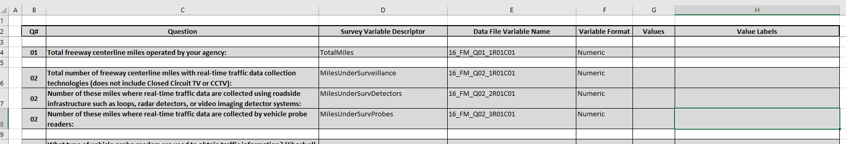
Figure 6: Data Dictionary Worksheet in Survey Data File

Variable Summary Statistics
Figure 7 includes an example of the Variable Summary Statistics (Var Summ Stats) worksheet. This worksheet summarizes several characteristics of each variable in the data file including the question number (Q#), the Data File Variable Name (used in the column headings of the data worksheet), the Survey Variable Descriptor, the Variable Format, and summary statistics for the variable based on the variable format where:
- Numeric – includes a count of the number of records with non-missing values and the sum of these values
- Boolean – a count of the responses for each possible response (N=No; Y=Yes; F=False; T=True)
- Multiple Choice – a count of the responses for each possible response in the survey
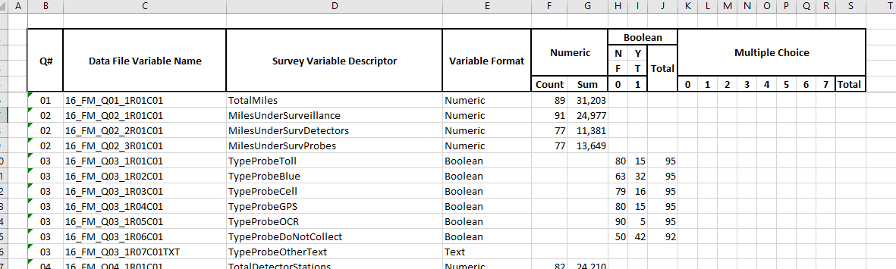
Figure 7: Variable Summary Statistics Worksheet in Survey Data File

Use Cases
This chapter presents two use cases as examples for how a user might use the common questions file to conduct different searches of past ITS Deployment Tracking Surveys (1999 – 2020).

Use Case 1: Extracting Data from Past ITS Deployment Tracking Surveys (1999 – 2020) for a Trend
The following steps may be used to examine a deployment trend for a particular technology (or other question) from past ITS Deployment Tracking Surveys (1999-2020):
- Open the relevant common questions file for the survey you are interested in (e.g., Freeway Management, Arterial Management, Transit Management) to the index worksheet.
- Locate the topic of interest in the ITS Deployment Tracking Survey by examining the topic and sub-topic information contained in the index worksheet.
- If the topic is contained in the ITS Deployment Tracking Survey, identify the questions asked (by year) and the name of the variables in the associated data file from the topic worksheet.
- Open the relevant Excel data file for each year containing the identified variable and extract the data associated with the variable.
The following example demonstrates how to locate trend data for a “Ramp Meters” Topic. In this case, the search identifies trends to the question: “Total number of metered ramps” for freeway management agencies.
Step 1: Open the index worksheet in the Freeway Management Common Survey Questions File and locate “Ramp Meters” topic.
Step 2: Determine if the topic of interest is included in the ITS Deployment Tracking Survey by examining the topic and sub-topic information contained in the index worksheet.
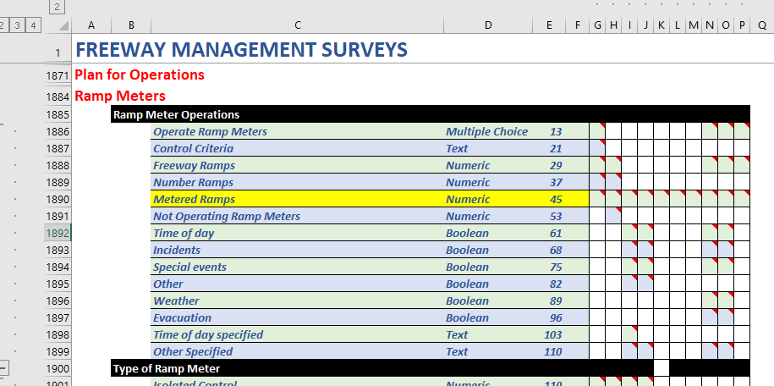
Figure 8. Use of the Index Worksheet to Identify Ramp Meter Questions

Notes: Expand the index worksheet to reveal topics and sub-topics. Topics are highlighted in red and sub-topics highlighted in black.
Notes: Expand a row under a sub-topic to reveal the subject(s) addressed by survey question(s) along with the variable type and the row in the topic worksheet containing information related to the question. In this example, “Metered Ramps” is in numeric format and located in row 45 of the “Ramp Meters” topic worksheet.
Step 3: Identify the questions asked, the names of the variables, and the associated data files (survey year) by opening the “Ramp Meters” topic worksheet and locating the row containing “Metered Ramps.”
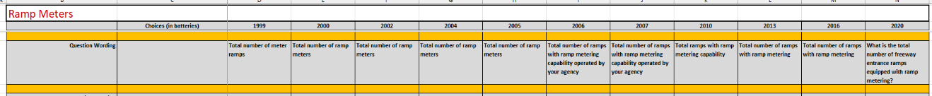
Figure 9. Use of the “Ramp Meters” Tab to Identify Trend for the Metered Ramps Question
Notes: Note that the question has been asked each year between 1999 and 2020. Capture the variables names for each year for use in extracting data from each data file.
Step 4: Download the datasets for each year and run summary statistics on the ramp meter variable for each survey year.
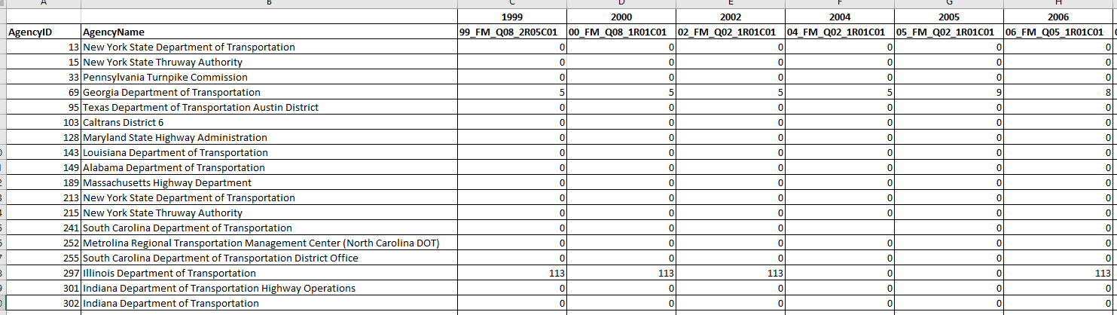
Figure 10. Metered Ramps Data Extracted From Multiple Surveys
Notes: This example table consists of data extracted from each data file for the appropriate variable. In this case, the values displayed are the number of metered ramps operated by an agency for each year. Data must include the Agency Identification (ID) from each file (for merging).

Use Case 2: Extracting Data from Past ITS Deployment Tracking Surveys (1999 – 2020) for a Particular Agency
Each agency surveyed was assigned a unique Agency ID used each year to facilitate the ability to extract data for a particular agency both within a survey year and across survey years. The example below demonstrates how a user can extract a response for a Freeway Management question (covering the survey period 1999 – 2020) for the New York State Department of Transportation in the Albany, NY Metropolitan Area (Agency ID = 13). Some agencies answered both Freeway Management and Arterial Management surveys and this number is the same for both surveys.
The following steps can be used to extract data for a specific agency from past ITS Deployment Tracking Surveys:
- Open the common questions file to the index worksheet.
- Determine if the topic of interest is included in the ITS Deployment Tracking Survey by examining the topic and sub- topic information contained in the index worksheet.
- If the topic is contained in the ITS Deployment Tracking Survey, identify the questions asked and the name of the variables in the associated data file from the topic worksheet (note question could be asked over multiple years).
- Open the relevant agency data file(s) for the year(s) containing the variable and extract the data associated with the variable for post-processing.

If the user knows the data and variable names of interest, then the user may go directly to the data file to extract the data. Please note that data for a specific agency may not be available every year the survey was conducted because the specific agency may not have responded in each survey year.
The following example demonstrates how to locate survey archive data for an agency (Agency ID = 13) on a “Connected Vehicles (CV)” topic. In this case, the search identifies the responses available in past ITS Deployment Tracking Surveys to the question: “Does your agency have plans to deploy connected vehicle applications?” for freeway management agencies.
Step 1: Open the index worksheet in the Freeway Management Common Survey Questions Workbook and locate CV topic.
Step 2: Examine the topic and sub-topic information contained in the index worksheet.
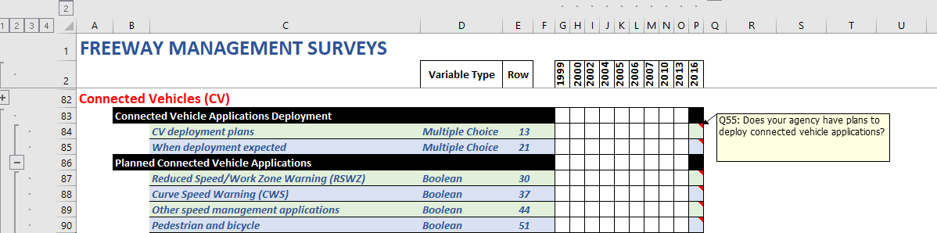
Figure 11. Use of the Index Worksheet to Identify Connected Vehicle Questions
Notes: Expanding the index worksheet to reveals the sub-topic “Connected Vehicle Applications Deployment” and the question “Does your agency have plans to deploy connected vehicle applications?”
Step 3: Identify the questions asked and the name of the variables in the associated data file by opening the CV topic worksheet.
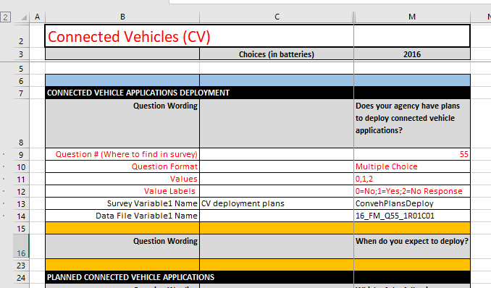
Figure 12. Use of the “Connected Vehicles” Tab to Obtain Information About the Connected Vehicle Applications Question
Notes: Data for this question are located in the 2016 Freeway Management data file and the variable name in the file is “16_FM_Q55_1R01C01.”
Step 4: The user may acquire the information they need simply by viewing the data (e.g., the file shows that in the 2016 ITS Deployment Tracking Survey, the New York State Department of Transportation in Albany, NY reported that it did not operate or plan to operate CV applications. If additional analysis is required, the user can download the relevant data file containing the variable“16_FM_Q55_1R01C01.”
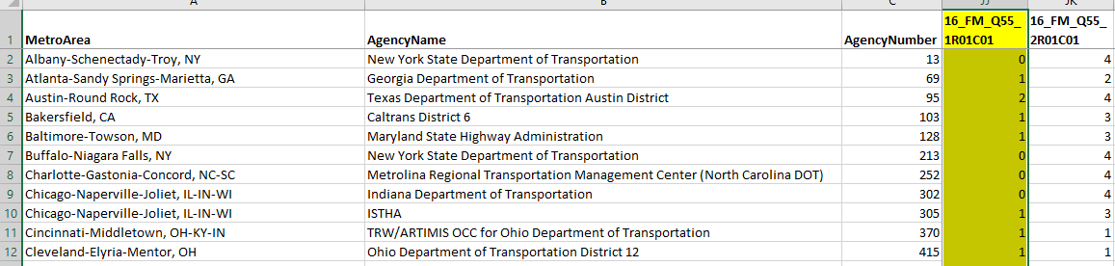
Figure 13. 2016 Connected Vehicle Data for New York State Department of Transportation
- Revisions to Metropolitan Statistical Areas
Revisions to Metropolitan Statistical Areas (MSA) were established on June 6, 2003, in Office of Management and Budget (OMB) Bulletin No. 03-04, following initial publication on December 27, 2000, in the Federal Register (65 FR 82228 – 82238). Eight metropolitan areas in the survey population changed boundaries: two metropolitan areas were combined into one, and seven metropolitan areas were divided (Table 1). These updates appear to have been incorporated into the ITS Deployment Tracking Survey with the 2010 survey cycle. However, the updates only resulted in changes to the census designation of surveyed agencies; the agencies being surveyed remained consistent over time.
Table 1. Substantial Changes in Metropolitan Statistical Area Definitions
Original MSA Surveyed in ITS Deployment Tracking Survey | MSA Name Added to ITS Deployment Tracking Survey | Description of Change
Cleveland-Elyria-Mentor, OH | Akron, OH | Akron, OH MSA split from Cleveland-Elyria-Mentor, OH
New Haven-Meriden, CT | Bridgeport-Stamford-Norwalk, CT | Bridgeport-Stamford-Norwalk, CT split from New Haven-Meriden, CT
Raleigh-Cary, NC | Durham, NC | Durham, NC split from Raleigh-Cary, NC
Miami- Fort Lauderdale, FL and  West Palm Beach-Boca Raton, FL | Miami-Fort Lauderdale-Pompano Beach, FL | Two original MSAs were combined into one: Miami-Fort Lauderdale-Pompano Beach, FL
Salt Lake City, UT | Ogden-Clearfield, UT | Ogden-Clearfield, UT split from Salt Lake City, UT
Los Angeles-Long Beach-Santa Ana, CA | Riverside-San Bernardino-Ontario, CA | Riverside-San Bernardino-Ontario, CA split from Los Angeles-Long Beach-Santa Ana, CA
San Francisco-Oakland-Freemont, CA | San Jose-Sunnyvale-Santa Clara, CA | San Jose-Sunnyvale-Santa Clara, CA split from San Francisco-Oakland-Freemont, CA
Greensboro-High Point, NC | Winston-Salem, NC | Winston-Salem, NC split from Greensboro-High Point, NC

U.S. Department of Transportation
ITS Joint Program Office – HOIT
1200 New Jersey Avenue, SE
Washington, DC 20590
Toll-Free “Help Line” 866-367-7487
www.its.dot.gov
FHWA-JPO-24-142


An initial exploratory survey was conducted in 1997, but the questions and survey design changed significantly starting with the 1999 ITS Deployment Tracking Survey. Since the 1997 data are not comparable to any of the subsequent ITS Deployment Tracking Surveys, the 1997 data are not included in the data repository.
While it is possible to trend 2023 questions with questions in past ITS Deployment Tracking Surveys (1999-2020), where the question wording is comparable and sample sizes are sufficient, the 2023 data will need to be filtered on agencies that are part of the historical ITS Deployment Tracking Survey sample.
Intelligent Vehicle-Highway Systems; Early Deployment Planning Program, Federal Register 94-13167, https://www.federalregister.gov/documents/1994/05/31/94-13167/intelligent-vehicle-highway-systems-early-deployment-planning-program.
The three metropolitan areas included were Albuquerque, New Mexico; San Juan, Puerto Rico; and Sarasota-Bradenton, Florida.
Tracking the Deployment of the Integrated Metropolitan Intelligent Transportation Systems Infrastructure in the USA:FY 1997 Results, FHWA-JPO-99-001, https://rosap.ntl.bts.gov/view/dot/2435.
Federal Highway Administration
Federal Transit Administration
These surveys were consolidated into a single “Arterial Management Survey” starting with the 1999 ITS Deployment Tracking Survey.
Federal Highway Administration, Highway Statistics 2000, https://www.fhwa.dot.gov/ohim/hs00/.
For more information on sampling methodology see Intelligent Transportation Systems: Findings from the Small Urban and Rural Transit Provider Survey, FHWA-ITS-20-799, https://rosap.ntl.bts.gov/view/dot/50549.
The name of an agency may have changed over time because of realignment due to administrative boundary changes due to US Census updates over time.

